Name: _______________________________________________________ Date: __________

ASTRONOMY
Photograph of the Week
August 9, 2021

Look at the photograph provided below. Study it for visual detail.

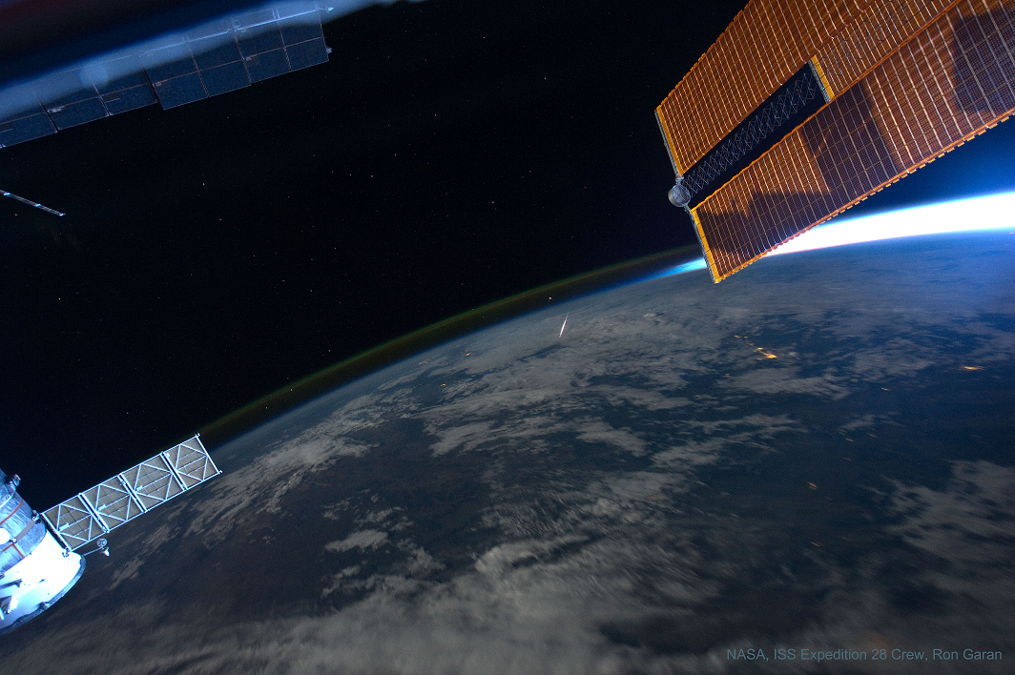

Identify or describe five (5) different visual phenomena that you see in the photograph. The phenomena can be natural or manmade. Type your responses into the blocks. Type in complete sentences.

You will share out 1 or 2 of your observations in class.
Submit your assignment to CTLS student uploads by 4:00 PM today.

1.

2.
3.
4.
5.

What is the most interesting, exciting, or unexpected item or part of the photograph? Explain why.

